**LONDON MARATHON**

**MAIN ALLOCATION OF PLACES**

There were 50,000 participants in October 2022. <https://www.tcslondonmarathon.com/news-and-media/media-resources/2022-tcs-london-marathon-stats>

**NON-CHARITY PLACES**

|  |  |  |
| --- | --- | --- |
| BALLOT PLACES (costing £50 each) |  | 17,000-20,000 |
| CLUB PLACES per club (costing £50 each)  (Depending on first claim registered members) | 10-150  151-250  251-350  350+ | 1  2  3  4 |
| PLACES FOR CLUBS VOLUNTEERING  Per club |  | 2 |
| GOOD FOR AGE PLACES |  | 6000 |
| CHAMPIONSHIP PLACES |  | Not specified |
|  |  |  |
|  |  |  |
|  |  |  |

**IN TOTAL ONLY 1000 CLUB PLACES ARE AVAILABLE**

**CHARITY PLACES**

750 charities hold 15,000 places between them.

There are nearly 20 charities packages on offer, starting at a cost to the charities of £2,500 which includes one guaranteed place. LM charge up to £22,250 for a Gold charity package which includes 8 guaranteed places. LM decline to say how many places are available via advertising packages. Most charity places go to big charities and small charities are generally overlooked. Places are offered to small charities on a rota basis. <https://www.civilsociety.co.uk/news/charities-charged-thousands-of-pounds-for-packages-to-london-marathon.htmbarnados>

Barnado’s (one of the biggest charities) charges their runners a £100 entry fee with a minimum sponsorship donation of £2200. This puts runners under enormous pressure and two people were seen walking with crutches this year probably due to the pressure put upon them to finish even though they were injured.

**TOTAL APPLICANTS AND STARTERS SINCE 1981**

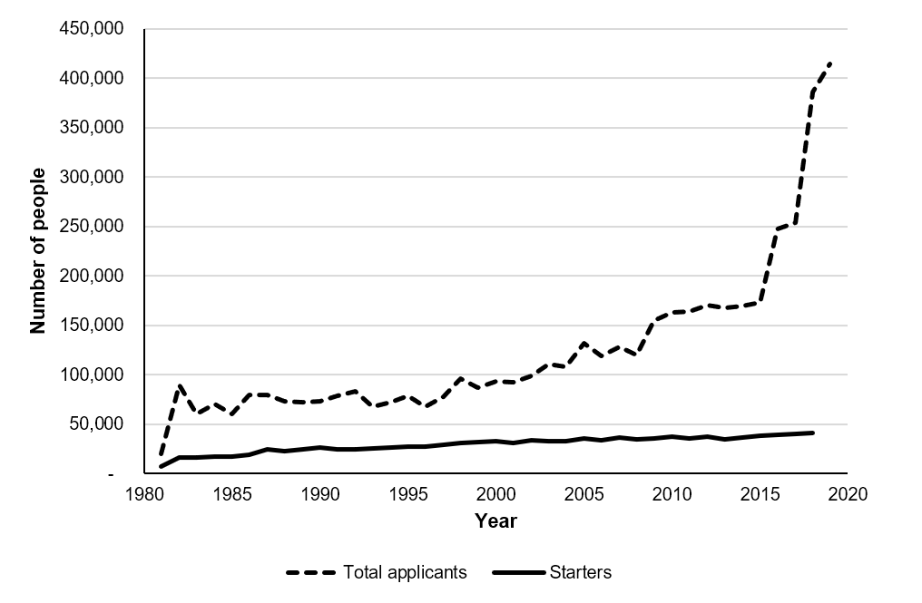https://www.significancemagazine.com/sports/601-still-running-against-the-odds-revisiting-the-london-marathon-ballot

There has been a surge in popularity since 2008, despite a lack of inspiring performances (from UK), with a spike in 2015. Second, there has also been a change in the way the “good for age” automatic places are assigned.

Recently, the wave system was introduced to allow the spread of the peak but which also allowed the numbers of runners to be increased. This is thought to be less than 10% however and it is now thought that capacity is at its maximum.

There are approx 13 water stations and 4 Lucozade stations on route (a total of approx. 17).

Each station requires 60 helpers (therefore there are approx. 1000 volunteers in total on these stations plus many others in different roles).

Our point is that in the 1990’s IAC were offered 11 places for volunteering, which was reduced to 6 up until recently and now we are offered only 2. As you can see, applications for the LM have risen exponentially in recent years and the total number of runners has increased yearly. IAC have helped out at the LM since the beginning (as have other clubs), making this a commitment of 40+ years, however, goodwill seems to have gone out of the equation and it is now questioned whether we want to continue to volunteer. If each group of volunteers were offered 8-10 places (rather than 2), this would only increase the number of runners from these groups by about 150-200 and it is difficult to see why LM cannot meet these criteria. Runners who are offered club places still have to pay so nothing is lost! The bottom line is in the phrase: ‘The increase in applicants led to a squeeze of the entry system in 2019. First, the number of places available to running clubs (THE FOUNDATION OF THE UK ATHLETICS SYSTEM) has roughly halved’.

If we do decide not to volunteer this year, we can still choose a place to meet, support and take a picnic! There is no pressure but it would be good to hear everyone’s views then I can put it to other local clubs and forward our opinions to the LM.